**LAB REPORT NO 11**



Submitted by:  **Muhammad Ali**

Registration No: - **19PWCSE1801**

Class Section: A

“On my honor, as student of University of Engineering and Technology, I have neither given nor received unauthorized assistance on this academic work.”

Submitted to:

**Engr. Durr-e-Nayab**

Data:(12,08,2021)

Department of Computer Systems Engineering

University of Engineering and Technology, Peshawar

**Objectives of this lab: -**

* To learn how to determine Fourier series representation of signal.
* To understand time reversal property.
* To understand time scaling property.
* Fourier series coefficient of signal.

**Given the signal x(t) with ak’s**

**a) Plot the time reverse version of the signal x(‐t) directly,**

**b) Plot FS coefficients a‐k of time reversed signal,**

**c) Plot the reconstructed time reversed signal using FS coefficients a‐k**

**Hint : use bk = fliplr(ak); for flipping the ak’s.**

**Example – Demonstration of Time Scaling Property of FS having α = 0.5**

**Matlab code: -**

**Task no 1: -**

clc

clear all

close all

% FS coefficients of periodic square wave

k = -50:50;

T = 1;

T1 = 0.25;

% Manual correction for a0 ?> ak(51)

t = -1.5:0.005:1.5;

ak =sin(k*2*pi*(T1/T))./(k*pi);

ak(51)=2*T1/T;

w0 = 2*pi/T;

xt = zeros(1,length(t));

% t0 time shift

for k = -50:50

xt = xt + ak(k+51)*exp(j*k*w0*t);

end

x=fliplr(xt);

tr=fliplr(t);

a = zeros(1,length(t));

for k = -50:50

a =a+ak(k+51)*exp(j*k*w0*t);

end

bk=fliplr(a);

figure(1);

plot(tr,x,'lineWidth',2);

xlabel('t');

ylabel('x(-t)');

title('Periodic Square Wave with -ak’’s time reversal');

axis([-1.5 1.5 -1.2 1.2]);

grid;

figure(2);

plot(tr,bk,'lineWidth',2);

xlabel('t');

ylabel('x(-t)');

title('FS coefficients -ak of time reversed signal');

axis([-1.5 1.5 -0.2 1.2]);

grid;

figure(3);

plot(t,real(-xt),'lineWidth',2);

xlabel('t');

ylabel('x(-t)=x(t?0.5)');

title('Reconstruction from ak''s with 101 terms');

axis([-1.5 1.5 -1.2 0.2]);

grid;

**discussion**: -

we perform time reversal operation of square wave signal by reversing its time x-axis.

a)

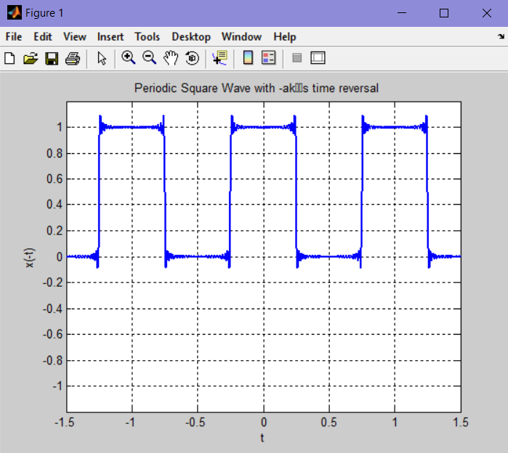

b).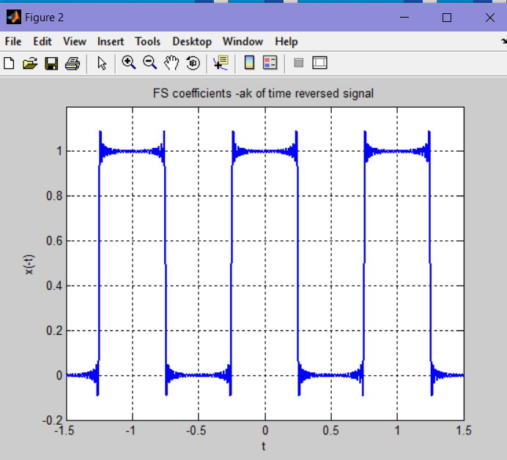

c).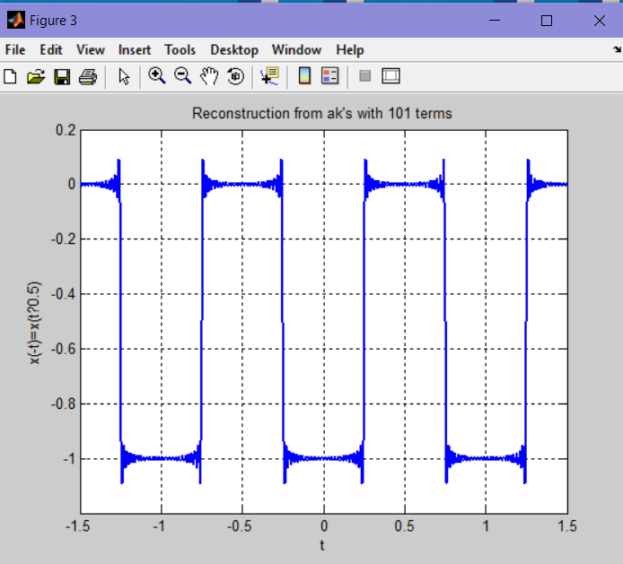

**Given the periodic square wave x(t) with T = 1 & T1 = 0.25, rewrite the above code for time**

**scaling when value of alpha is 2 i.e. x(αt) = x(2t).**

**Task no 2: -**

clc

clear all

close all

% Generation of periodic square wave

t =-1.5:0.005:1.5;

xcos = cos(2*pi*t);

xt = xcos>0;

% FS coefficients of periodic square wave

k = -50:50;

T = 1;

T1 = 0.25;

ak = sin(k*2*pi*(T1/T))./(k*pi);

ak(51) = 2*T1/T; % Manual correction for a0 ?> ak(51)

% Time scaling parameters

alp1 = 2;

% w's for the time scaled signals

w0 = 2*pi/T;

w1 = alp1*w0;

% Reconstruction from ak's with 101 terms (M=50)

xat1 = zeros(1,length(t));

for k = -50:50

xat1 = xat1 +ak(k+51)*exp(j*k*w1*t);

end

figure(1);

subplot(2,1,1);

plot(t,xt,'lineWidth',2);

ylabel('x(t)');

title('Periodic Square Wave (T=1, T1=0.25)');

axis([-1.5 1.5 -0.2 1.2]);

grid;

subplot(2,1,2);

plot(t,real(xat1),'lineWidth',2);

ylabel('x(t)');

title('Reconstruction from ak''s (alp1=2, w1=2*w0)');

axis([-1.5 1.5 -0.2 1.2]);

grid;

**Discussion: -**

In this task we represent Fourier series of a square wave signal (xcos = cos(2*pi*t)), and then scale its time with factor of 2 which is called time scaling of signal.

Output: -

